American Government: Origins Jigsaw
- What is your source? Who is the author and where/when is it from?

- What is the author’s thesis/main idea?

- How does the author support their thesis/main idea?

- How does this source reflect Enlightenment thinking?

Excerpt from the Autobiography of Benjamin Franklin: Part 1
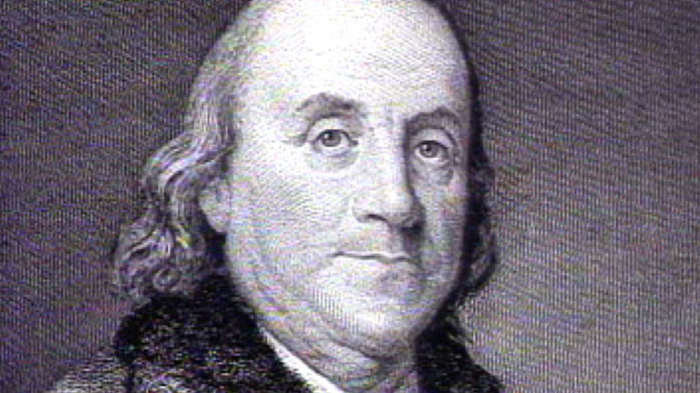

Before I enter upon my public appearance in business, it may be well to let you know the then state of my mind with regard to my principles and morals, that you may see how far those influenced the future events of my life. My parents had early given me religious impressions, and brought me through my childhood piously in the Dissenting way. But I was scarce fifteen when after doubting, by turns, of several points as I found them disputed in the different books I read, I began to doubt of Revelation itself. Some books against Deism fell into my hands; they were said to be the substance of sermons preached at Boyle's Lectures. It happened that they wrought an effect on me quite contrary to what was intended by them; for the arguments of the Deists, which were quoted to be refuted, appeared to me much stronger than the refutations; in short, I soon became a thorough Deist. My arguments perverted some others, particularly Collins and Ralph; but each of them having afterwards wronged me greatly without the least compunction, and recollecting Keith's conduct towards me (who was another free-thinker) and my own towards Vernon and Miss Read, which at times gave me great trouble, I began to suspect that this doctrine, tho' it might be true, was not very useful. My London pamphlet, which had for its motto these lines of Dryden:
Whatever is, is right. Though purblind man Sees but a part o' the chain, the nearest link: His eyes not carrying to the equal beam, That poises all above; and from the attributes of God, His infinite wisdom, goodness, and power, concluded that nothing could possibly be wrong in the world, and that vice and virtue were empty distinctions, no such things existing, appeared now not so clever a performance as I once thought it; and I doubted whether some error had not insinuated itself unperceived into my argument, so as to infect all that followed, as is common in metaphysical reasonings.

I grew convinced that truth, sincerity, and integrity, in dealings between man and man, were of the utmost importance to the felicity of life; and I formed written resolutions, which still remain in my journal-book, to practice them ever while I lived. Revelation had indeed no weight with me, as such; but I entertained an opinion that, though certain actions might not be bad because they were forbidden by it, or good because it commanded them, yet probably those actions might be forbidden because they were bad for us, or commanded because they were beneficial to us, in their own natures, all the circumstances of things considered. And this persuasion, with the kind hand of Providence, or some guardian angel, or accidental favorable circumstances and situations, or all together, preserved me through this dangerous time of youth, and the hazardous situations I was sometimes in among strangers, remote from the eye and advice of my father, without any willful gross immorality or injustice, that might have been expected from my want of religion. I say willful, because the instances I leave mentioned had something of necessity in them, from my youth, in inexperience, and the knavery of others. I had therefore a tolerable character to begin the world with; I valued it properly, and determined to preserve it.

