Civil Disobedience Timeline
Your assignment is to create a timeline focusing on civil disobedience in American society. You need to choose TEN events that you think best demonstrate civil disobedience. The timelines must be on a poster board and should look neat and professional. Each event must be dated, placed in chronological order, and accompanied by a picture and a paragraph that…
- Describes the event that took place
- Explains why the action taken was considered deviant
- Identifies the goals of those participating
- Identifies the sanctions faced by those committing the act of civil disobedience
- Explains why the event was socially significant
The paragraphs can either be on your timeline or handed in separately. Paragraphs need to be…
- TYPED
- DOUBLE SPACED
- TIMES NEW ROMAN 12 PT. FONT
You will have two days in the computer lab to work on this project so make good use of your time!

Example
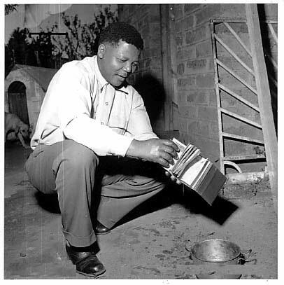
During the apartheid era in South African, black citizens were required to carry passbooks that identified their race and where they lived. Without a passbook people were not allowed to travel to different areas of the country. Nelson Mandela committed an act of civil disobedience by burning his pass book. This action was considered deviant because black South Africans were considered second-class citizens and Mandela was signifying that he refused to accept that assigned role. Mandela’s intention was to bring attention to the injustice and inequality in his country in hopes of initiating social reform. His continued efforts eventually landed Mandela in prison for twenty-seven years. While in prison, Mandela became a symbol for South African freedom. There were many “Free Mandela” protests which led to international support for his cause as well as economic sanctions against the South African government. When segregation ended Mandela was released from prison and was elected as the nation’s president in 1994.

